BiscuitAI: Facial Landmark Detection and Behavior Analysis

Introduction 3
Step-by-Step Analysis 3
1. Mediapipe Model Overview 3
2. Eyes Open/Closed Detection 3
2.1 Approach 3
2.2 Landmark Detection: 4
2.3 EAR Calculation: 4
2.4 Threshold-Based Classification: 4
2.5 Visual Output: 4
3. Gaze Estimation 5
3.1 Approach 5
3.2 Eye Open/Closed Detection 5
3.3 Head Orientation (Yaw, Pitch, Roll) 5
3.4 Gaze Estimation 6
3.5 Results 7
4. Head Positioning and Orientation 9
4.1 Approach # 1 : Considering Full Frame 9
4.1.1 Facial Landmark Detection 10
4.1.2 Bounding Box Calculation 10
4.1.3 Percentage Position Relative to Frame 10
4.1.4 Horizontal Position Labeling 10
4.1.5 Results 11
4.2 Approach 2: Center of the Image as Origin 12
4.2.1 Results 13
5. Distance Estimation 14
5.1 Approach 14
5.2 Approach 14
5.2.1 Extracting Face Landmarks 14
5.2.2 Measure Face Height in Pixels 14
5.2.3 Estimating Distance Using the Pinhole Camera Model 14
5.2.4 Categorizing the Distance 15
5.2 Problems Faced 15
5.3. Solutions 16
5.4. Results 16
5.5 Integrated Feedback 21
5.5.1 Distance Categories: 21
5.5.2 Improved Logic For Distance 21
6. Lips Movement Analysis 22
6.1 Approach 22
6.1.1 Lip Distance Calculation and Smoothing: 22
6.1.2 Speech Detection Through Dynamic Movement: 22
6.2 Feature Breakdown 22
6.2.1 Lip Distance Calculation and Smoothing 22
6.2.2 Speech Detection Through Dynamic Movement 24
6.3 Lip Movement Results 25
Remarks: 25
7. Combined Results: 26
7.1 Demonstration 26

Introduction
This document provides a detailed development overview for solving the problem of real-time facial landmark detection and behavior analysis. It focuses on implementing a system capable of detecting and interpreting user behavior through features such as eye status detection, gaze direction analysis, and lip movement tracking. By leveraging Mediapipe's FaceMesh framework, the project aims to build a reliable, real-time solution that can be integrated into mobile or kiosk-based applications, enhancing interactive user experiences. This analysis highlights the step-by-step implementation, beginning with the "Eyes Open/Closed" detection feature, which serves as a foundation for understanding user engagement and focus.

Step-by-Step Analysis

1. Mediapipe Model Overview
- Framework: The MediaPipe Face Landmarker is a machine learning solution designed to detect facial landmarks and expressions in images and videos. It identifies 3D facial landmarks, computes blendshape scores to represent facial expressions, and provides transformation matrices for rendering effects. This functionality is essential for applications such as human facial expression recognition, applying facial filters and effects.
- Core Features:
  - Real-time analysis on both video streams and static images.
  - Resolution-agnostic due to normalized coordinates.
  - Optimized for edge devices, ensuring low latency in deployment.
- Advantages:
  - Pre-trained models for accurate facial behavior analysis.
  - Cross-platform compatibility, allowing seamless integration into Python or Android environments.
  - Efficient computational performance, ideal for real-time applications

2. Eyes Open/Closed Detection
Objective: To detect whether a user's eyes are open or closed in real-time by analyzing geometric properties of eye landmarks.

2.1 Approach
- Uses the Eye Aspect Ratio (EAR), a geometric metric that reflects the openness of the eye.
- EAR is compared to a predefined threshold (e.g., 0.2) to classify the eye status.

2.2 Landmark Detection:
- The Mediapipe model extracts specific eye-related landmarks.
- Landmarks are converted to pixel coordinates based on the video frame dimensions.

2.3 EAR Calculation:
- The vertical and horizontal distances between key eye landmarks are computed using Euclidean geometry.
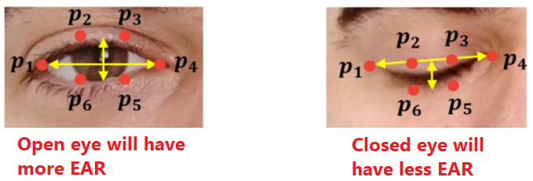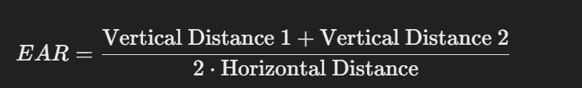

2.4 Threshold-Based Classification:
- If EAR falls below the threshold for multiple consecutive frames, the status is flagged as "Eyes Closed".
- Ensures robustness by filtering out false positives during blinking.

2.5 Visual Output:
- Displays EAR values and real-time status ("Eyes Open" or "Eyes Closed") on the video feed.
- Eye landmarks are highlighted for clear visualization.

3. Gaze Estimation
Objective: To trace the gaze of the user if they are looking at the camera or away in real-time using geometric properties of the pupil landmarks and the corners of the eyes.

3.1 Approach
- Facial Landmark Detection: Detects facial landmarks using Mediapipe Face Mesh to locate the eyes, iris, and key reference points for head orientation.
- Eye Open/Closed Detection: Uses Eye Aspect Ratio (EAR) to determine if the eyes are open. Gaze detection is skipped if eyes are closed.
- Gaze Detection: Analyzes iris position relative to the eye and dynamically adjusts thresholds based on head orientation (yaw).

3.2 Eye Open/Closed Detection
- Same approach as mentioned before by using EAR calculation which uses vertical and horizontal distances between key eye landmarks.
- If the eyes open detection fails (falls below the threshold), it will not continue with the gaze estimation.

3.3 Head Orientation (Yaw, Pitch, Roll)
- Key facial landmarks (nose tip, chin, left/right eye corners) are used to compute head orientation:
  - Yaw: Horizontal head rotation (left/right).
  - Pitch: Vertical head tilt (up/down).
  - Roll: Clockwise/anticlockwise head tilt.
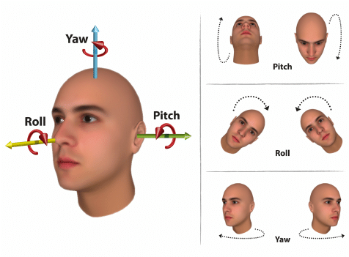
- Yaw calculation formula:


3.4 Gaze Estimation
- Iris position is calculated as the normalized distance from the iris center to the left corner of the eye:
  - Iris Position: Distance From Iris Center to Left Corner/ Eye Width
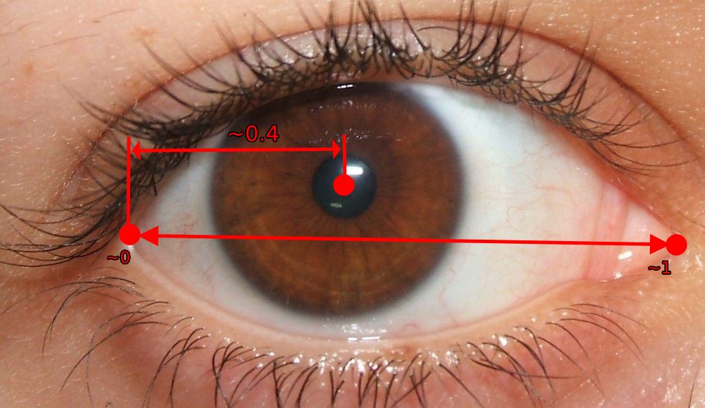

- Thresholds dynamically adjust based on yaw:
  - Yaw < -25: User is likely looking left.
  - Yaw > 20: User is likely looking right.

3.5 Results
- Looking at Camera:
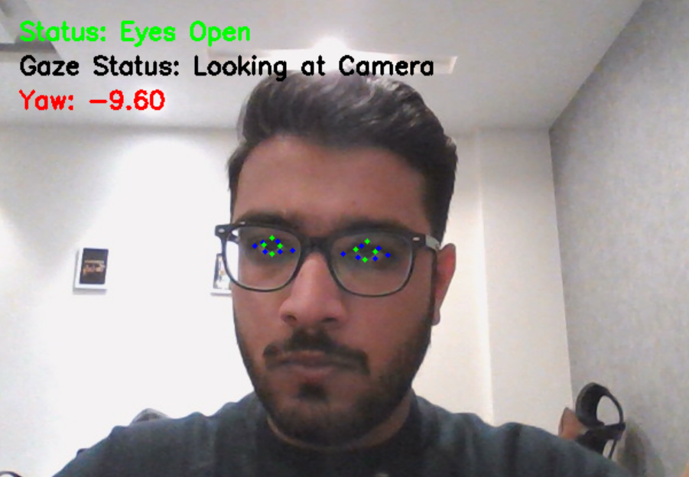

- Looking Away:

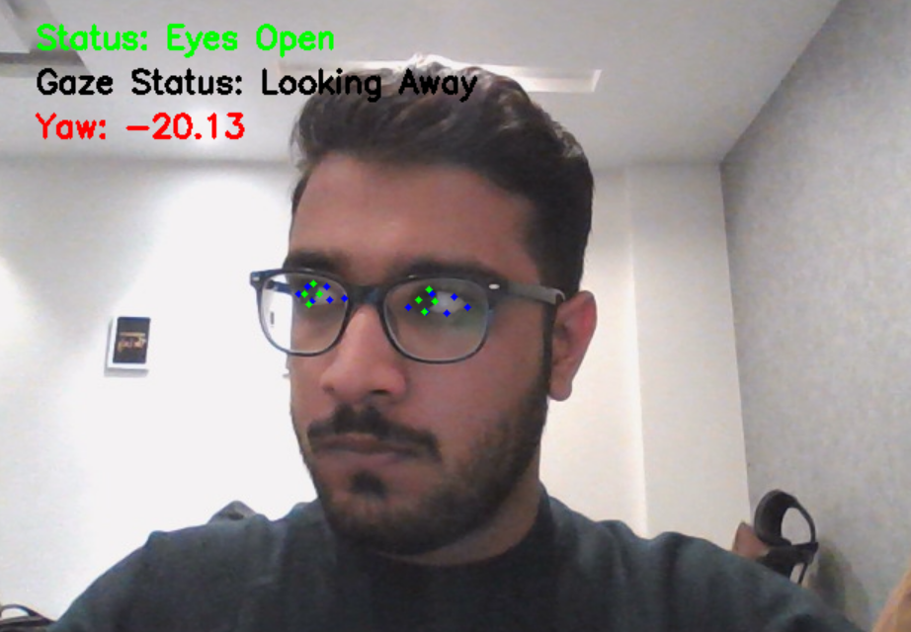

- Eyes Closed:



4. Head Positioning and Orientation
Objective: To create a system that accurately identifies and tracks the position of each user's head within a camera frame by leveraging facial landmark detection.

4.1 Approach # 1 : Considering Full Frame
- Facial Landmark Detection:Utilized Mediapipe's FaceMesh model to detect 468 facial landmarks in real time.
- Bounding Box Calculation: For each detected face, calculate a bounding box by iterating over all landmarks and identifying the minimum and maximum X and Y coordinates.
- Bounding Box Center: Determine the center of the face by calculating the midpoint of the bounding box diagonals.
- Position Relative to Frame: Based on the X percentage, label the horizontal position as either "Left" (if < 50%) or "Right" (if ≥ 50%).
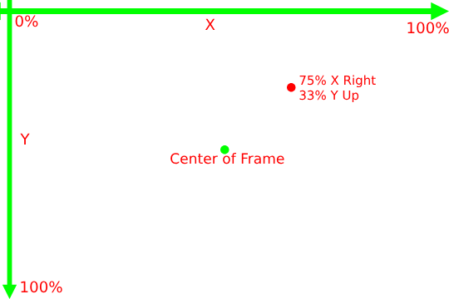
Figure: Calibration

4.1.1 Facial Landmark Detection
- Utilized Mediapipe's FaceMesh model to detect 468 landmarks on a face.
- Converted the input video frame to RGB format, as required by Mediapipe for processing.

4.1.2 Bounding Box Calculation
- cx_min, cy_min: Minimum X and Y coordinates of the landmarks, representing the top-left corner of the bounding box.
- cx_max, cy_max: Maximum X and Y coordinates of the landmarks, representing the bottom-right corner of the bounding box.

4.1.3 Percentage Position Relative to Frame
- Converted the bounding box center's X and Y coordinates into percentages relative to the frame dimensions:
X axis position = (Center_box_x /frame_width) * 100
Y axis position = (Center_box_y/frame_width) * 100
- Displayed the percentages on the frame for intuitive understanding of the face's position.

4.1.4 Horizontal Position Labeling
- Compared the X percentage to 50% (the midpoint of the frame):
  - "Left" if position_x_percent < 50.
  - "Right" if position_x_percent ≥50
- Labeled the horizontal position (Left or Right) on the frame for quick feedback

4.1.5 Results
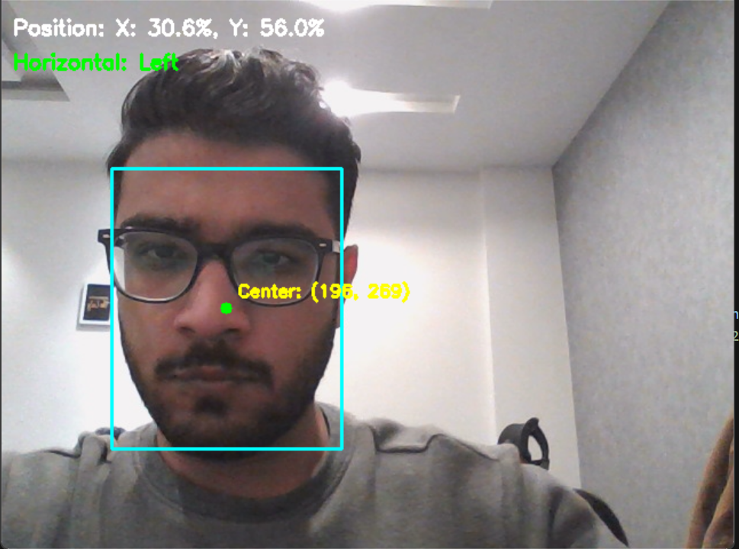
Face Detected on the left half of the frame
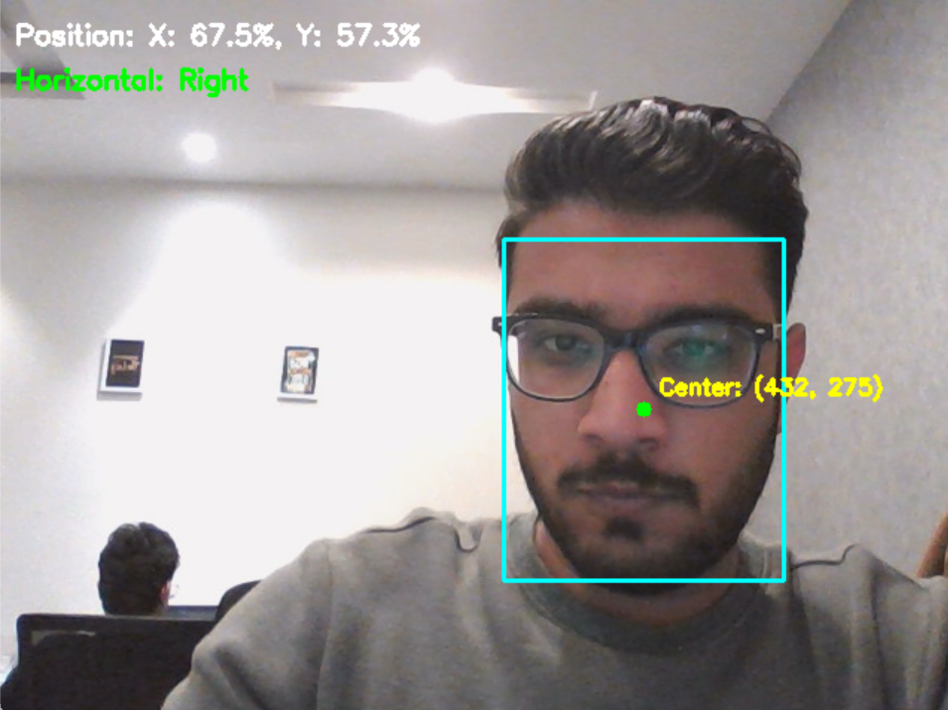
Face Detected on the right half of the frame

4.2 Approach 2: Center of the Image as Origin
Difference:
- Defines the center of the frame as the origin (0,0).
- Calculates offsets of the bounding box center (x,y) relative to the frame center in pixels.
- Converts these offsets into percentages of the half-frame dimensions for both X and Y axes.
- Interprets the percentages to classify positions as Left/Right (horizontal) and Up/Down (vertical).
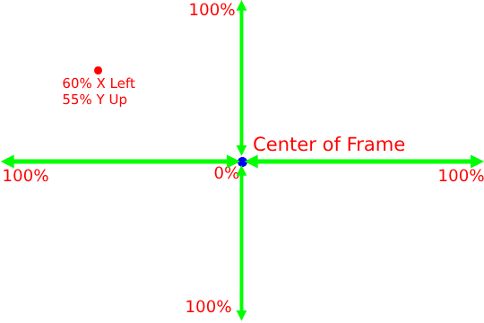
Figure: Calibration

4.2.1 Results
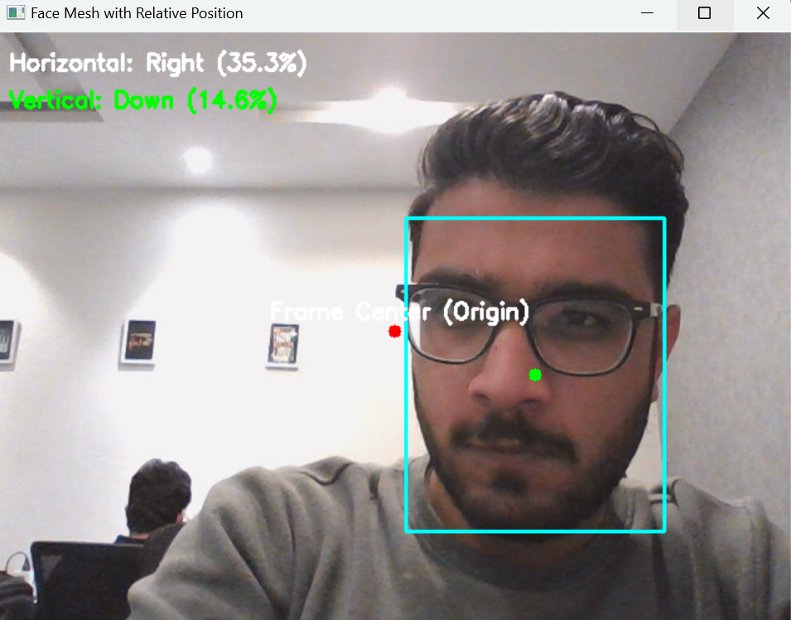
Fig: Results On Webcam Camera
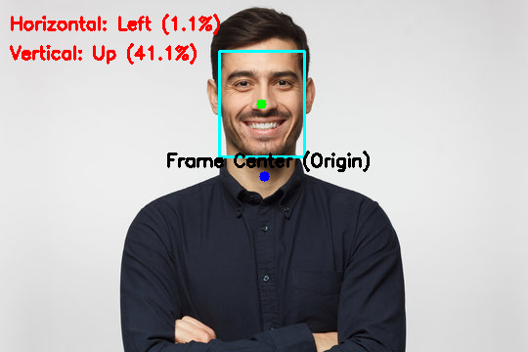
Fig: Results On Static Image

5. Distance Estimation

5.1 Approach
The system utilizes the FaceMesh model to estimate the distance of a person from the camera. Instead of relying on the full facial structure, we specifically focus on two landmarks: forehead (topmost point of the face) and chin (bottommost point of the face). The distance ratio between these landmarks and their pixel displacement in the image frame forms the basis for estimating the relative distance.
Additionally, we categorize the distance into four distinct classes:
- Too Close
- Close
- Far
- Too Far

5.2 Approach

5.2.1 Extracting Face Landmarks
- MediaPipe FaceMesh is used to detect facial landmarks in real-time.
- Each face landmark corresponds to a specific point on the face, identified by a unique index.
  - Forehead (landmark 10): Top of the face.
  - Chin (landmark 152): Bottom of the face.
- These landmarks are in normalized coordinates (values between 0 and 1 relative to the frame width and height).

5.2.2 Measure Face Height in Pixels
- The y-coordinates of the forehead and chin landmarks are used to compute the vertical height of the face in the image (in pixels).
face_height_pixels = abs(forehead_coords[1]-chin_coords[1])
- The landmarks' normalized values are multiplied by the frame's height to convert them into pixel coordinates.

5.2.3 Estimating Distance Using the Pinhole Camera Model
The pinhole camera model is used to calculate the approximate distance between the camera and the person’s face. The formula is:
distance = (self.focal_length * self.real_face_height) / face_height_pixels
- Focal length: Represents the camera's ability to focus and magnify objects. It is assumed to be 640 pixels in this code for the relation.
- Real-world face height: Assumed to be 20 (forehead-to-chin distance), which is an approximate average but also used as a constant.
- Face height in pixels: Measured from the image using the forehead and chin landmarks.
By applying this formula, we estimate the distance of the person’s face from the camera.

5.2.4 Categorizing the Distance
Once the distance is calculated, it is categorized into four classes:
- Too Close: Less than 45.
- Close: Between 45 and 90.
- Far: Between 90 and 180.
- Too Far: More than 180.
This categorization allows the system to provide intuitive feedback about how far the person is from the camera.

5.2 Problems Faced
- Inability to Estimate Exact Distance:
  - Determining an absolute distance (in meters or centimeters) directly from the camera without depth sensors was challenging due to the lack of real-world calibration.
- Head Orientation Issues:
  - When the person turned their head left or right, the facial landmarks shifted, causing inconsistencies in the calculated ratios.
- Facial Obstructions:
  - Partial visibility of the face, such as occlusions by hands or objects, led to difficulty in accurately detecting the forehead and chin landmarks.
- Variations in Lighting:
  - Low-light conditions occasionally caused the FaceMesh model to fail in detecting landmarks.
- Dynamic Camera Placement:
  - Different camera angles and heights affected the system's ability to generalize across all setups.

5.3. Solutions
- Adjustable Thresholds for Classes:
  - To address variability in distances, we introduced four distance classes with adjustable thresholds. This allows fine-tuning based on specific use cases or camera calibration.
- Using Forehead-to-Chin Ratio:
  - Focusing on these two specific landmarks made the system robust to head orientations (looking left or right). As long as these points were visible, the system could maintain consistency in distance estimation.
- Dynamic Calibration:
  - The system allows users to calibrate for their specific camera setup by providing real-world distances for initial measurements.

5.4. Results
The system was tested across a variety of scenarios and performed well under the following conditions:
- Controlled Distance Testing:
  - Too Close
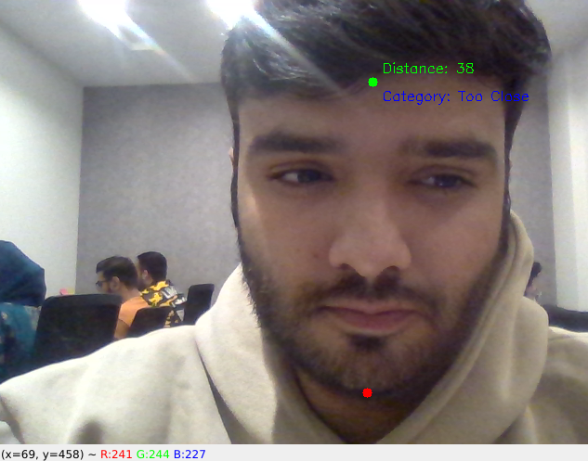
  - Close
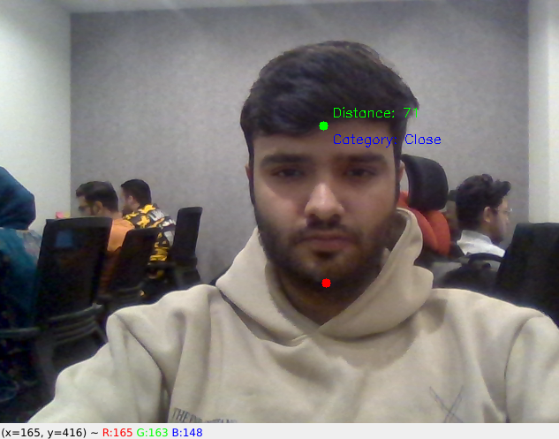
  - Far
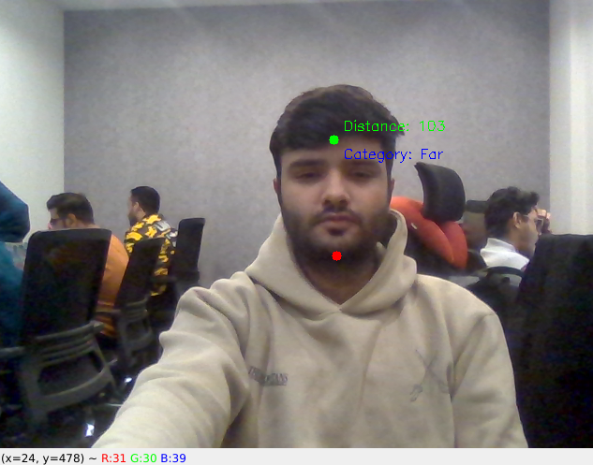

- Head Movement:
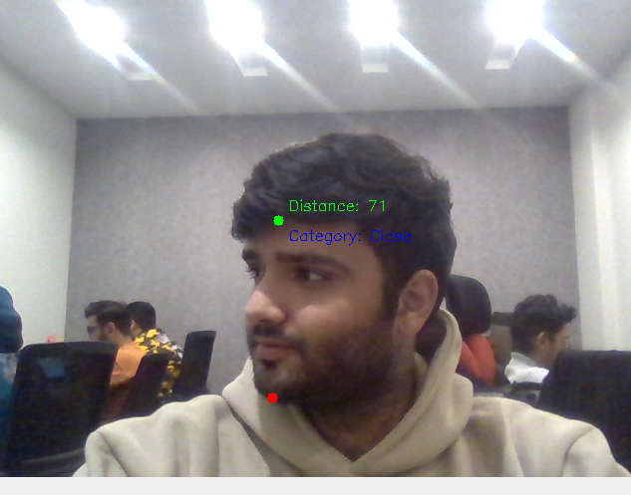
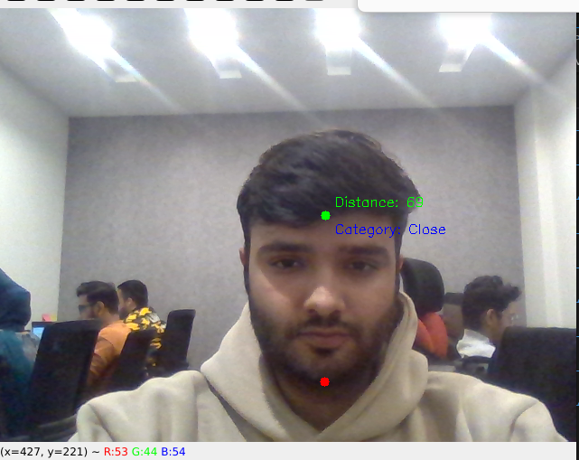
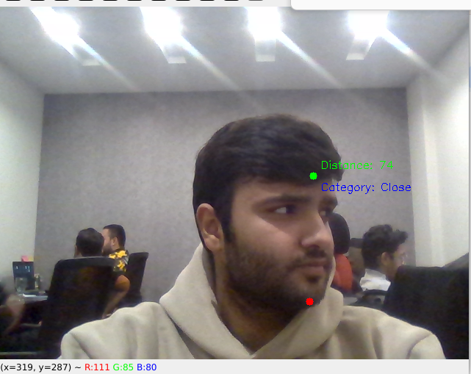
- Obstructions:
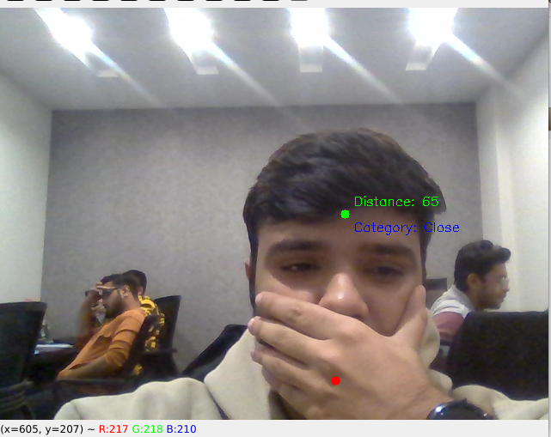
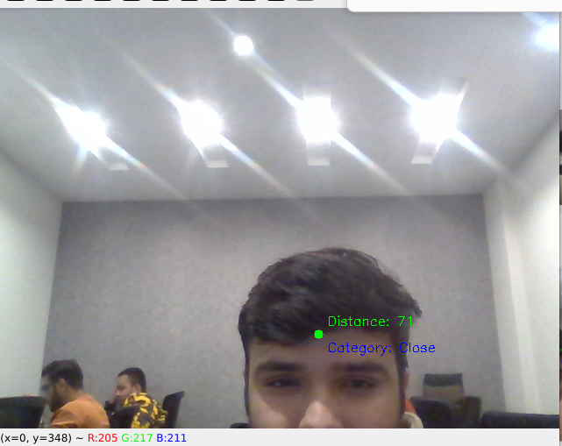

- Camera Angle:
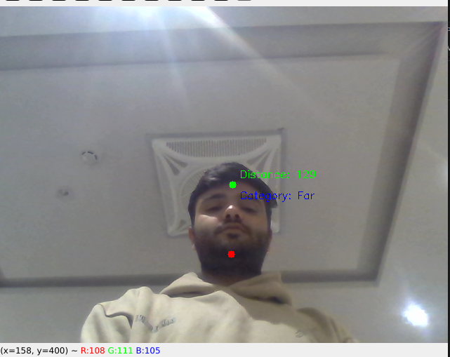
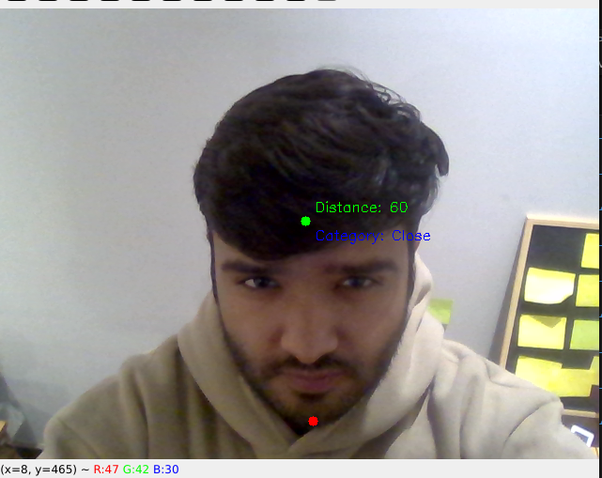

5.5 Integrated Feedback
After receiving feedback on the distance estimation module. There were some slight changes made to the logic and overall user experience of the displayed output.

5.5.1 Distance Categories:
The distance is divided into different categories:
- Distance less than 20 is considered: “Immediate”
- Distance between 20 and 45 is considered “Near”
- Distance between 45 and 90 is considered as “Mid Range”
- Distance between 90 and 180 is considered as “Far”
- Distance greater than 180 is considered as “Too far”

5.5.2 Improved Logic For Distance
There is a slight adjustment to the logic of this module. This is in regards to calculating distance based on the resolution of the screen. As the final deployment will be on different screen resolutions, the solution has to be adjusted accordingly.
The updated module will take into consideration the length and the width of the resolution of the frame and dynamically adjust the focal length. The rest of the calculations remain the same. This will allow the module to dynamically adjust the thresholding of the distance categories according to the available screen resolution.

6. Lips Movement Analysis
Objective: The Objective of this module is to use Mediapipe Facemesh landmarks to identify the lips of the user and then further analyze if the person is speaking. This is followed by advanced analysis to determine edge cases where the person lips are moving but not speaking (smiling and yawning)

6.1 Approach

6.1.1 Lip Distance Calculation and Smoothing:
- The system employs Mediapipe Face Mesh to track inner lip landmarks and calculates the vertical distance between them. To handle natural fluctuations, an Exponential Moving Average (EMA) is applied, ensuring smooth and realistic lip movement tracking.

6.1.2 Speech Detection Through Dynamic Movement:
- Lip distances are monitored over a sliding window of frames to evaluate consistent movement patterns. Speech is identified when the average lip distance surpasses a defined threshold and exhibits significant variation, distinguishing speaking activity from static lip movements like yawning or smiling.

6.2 Feature Breakdown

6.2.1 Lip Distance Calculation and Smoothing
This feature provides the foundation for accurate speech detection by tracking lip movements and filtering out noise through smoothing techniques.
- Facial Landmark Detection: Mediapipe Face Mesh is utilized to extract the coordinates of facial landmarks, with a focus on the inner lip points. The system calculates the vertical distance between the top and bottom inner lip landmarks as the primary metric for lip movement analysis.
  - Lip Distance Calculation: The Euclidean distance between the top and bottom inner lip points is computed:
lip_distance = np.linalg.norm(top_lip - bottom_lip)
- This measurement serves as an indicator of how open the mouth is during a given frame.
  - Exponential Moving Average (EMA) Smoothing: To reduce the effect of noise and fluctuations in individual frame calculations, an EMA is applied to the lip distance values. This provides a smoother and more stable measure of lip movement over time:
smoothed_lip_distance = ema_alpha * lip_distance + (1 - ema_alpha) * previous_lip_distance

6.2.2 Speech Detection Through Dynamic Movement
This feature enhances speech detection by evaluating both the magnitude and consistency of lip movement over time, ensuring accurate differentiation between speaking and non-speaking activities.
- Consistent Movement Analysis: A sliding window of recent lip distance values is maintained using a deque (FRAME_HISTORY). This history allows the system to monitor patterns in lip movement across multiple frames.
- Variation and Rate of Change: The system calculates the standard deviation of lip distances and evaluates the rate of change within the sliding window. A sufficient variation in lip movement over time, combined with a notable rate of change, is indicative of speaking activity.
- Threshold-Based Classification: Speech is detected based on two conditions:
  - Average Lip Distance: The average lip distance must exceed a predefined threshold (SPEECH_THRESHOLD), ensuring that the mouth is sufficiently open.
  - Movement Variation: The variation in lip movement (rate of change) must exceed a second threshold (RATE_OF_CHANGE_THRESHOLD), confirming consistent and dynamic lip movement.
This dual-threshold approach ensures reliable speech detection while filtering out static behaviors such as yawning, smiling, or holding the mouth open.

6.3 Lip Movement Results

Test Case | Scenario Description | Outcome
Baseline Speech | Speaking normally | Detects "Speaking"
Whispering | Minimal lip movement | Detects "Speaking"
Fast Speaking | Rapid lip movement | Detects "Speaking"
Yawning | Mouth open without movement | Detects "Silent"
Eating | Mimicking chewing | "Silent" if chewing with mouth closed
Smiling | Wide smile without movement | Detects "Silent"
Staring | No movement | Detects "Silent"
Random Movements | Exaggerated lip movements | Detects "Speaking"
Lighting | Various lighting conditions | Consistent detection
Background Noise | Noise without lip movement | Detects "Silent"
Moving Background | Dynamic background | Ignores background
Distance | Different distances | Accurate detection within range
Head Tilting | Various head angles | Consistent detection
Obstruction | Partially covered face | Detects "Silent" if blocked
Rapid Switching | Alternating speaking and silence | Matches actions
Continuous Monitoring | Long-term use | Stable and accurate

Remarks:
This algorithm performs effectively across various scenarios, offering reliable distance estimation by leveraging facial landmarks. Its simplicity and adaptability make it highly versatile. Knowing the kiosk's camera angle can further enhance precision by fine-tuning parameters like real-world face height or focal length. Since the thresholds and focal length are easily adjustable, this approach provides the flexibility to adapt to different setups or environments seamlessly at any time.

7. Combined Results:
In this section, we will highlight the output of the combined modules into a single frame. These modules will include the following modules:
- Eyes Open/Close Detection
- Eyes Gaze Detection
- Head Positioning
- Distance Estimation
- Lip Movement Detection

7.1 Demonstration

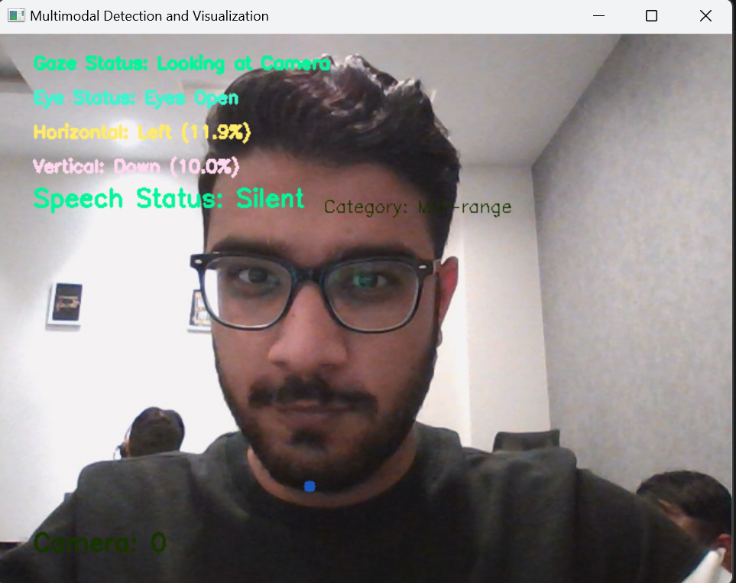
Figure 1: Looking at the camera and Silent.
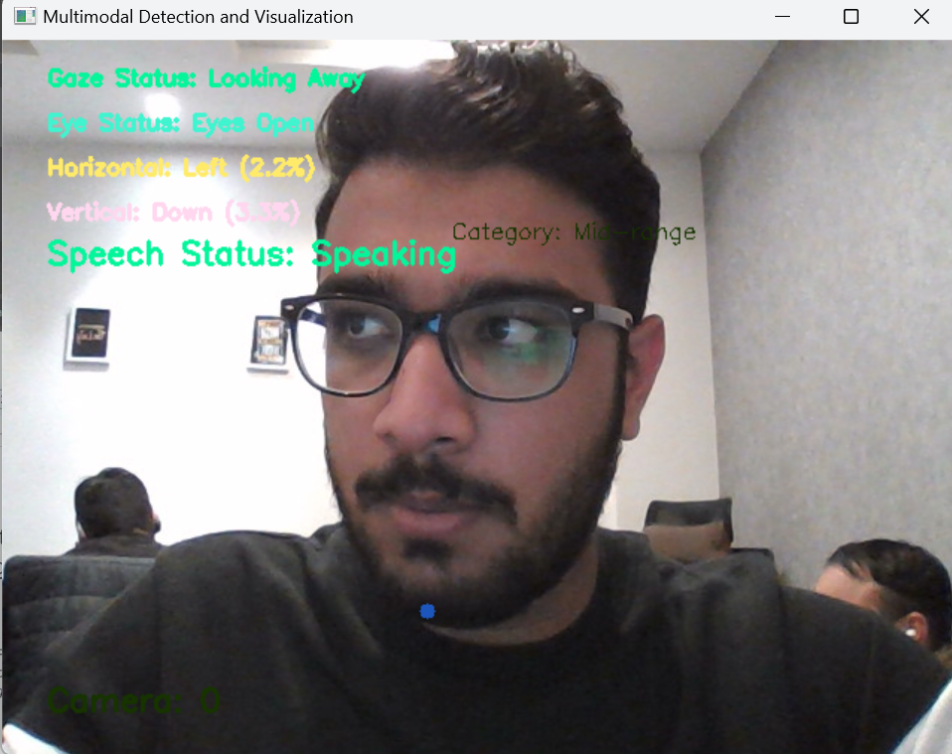
Figure 2: Looking away from the camera and speaking.

